June 6, 2018

Ms. Laurie Pysock Township Manager
East Marlborough Township 721 Unionville Road Kennett Square, PA 19348

RE: Douglas C. White – “Northridge” (Pavement Analysis Report)
Preliminary/Final Subdivision Plan Review
East Marlborough Township, Chester County, PA McMahon Project No. 817235.11

Dear Ms. Pysock:
McM AHON ASSOCI ATES, I N C.
840 Springdale Drive
Exton, PA 19341
p 610-594-9995 | f 610-594-9565
PRI NCI PALS
Joseph W. McMahon, P.E. Joseph J. DeSantis, P.E., PTOE
John S. DePalma William T. Steffens Casey A. Moore, P.E.
Gary R. McNaughton, P.E., PTOE
ASSOCI ATES
John J. Mitchell, P.E. Christopher J. Williams, P.E.
R. Trent Ebersole, P.E. Matthew M. Kozsuch, P.E. Maureen Chlebek, P.E., PTOE
Dean A. Carr, P.E.

In response to Comment No. 13 in the review letter from Vandemark & Lynch, Inc. dated April 26, 2018, McMahon Associates, Inc. has prepared this Pavement Analysis Report for the proposed residential development to be located along Gale Lane (T-502) in East Marlborough Township, Chester County, Pennsylvania. The noted comment recommends a “heavier pavement section” be utilized along “Road C” (Hunt Cup Drive) since the road will provide access to the existing industrial park.

In order to ensure an adequate, cost effective and structurally reliable pavement section is proposed in conjunction with the Development, a DARWin Pavement Analysis was completed. The analysis was completed by utilizing soil data collected from a USDA Soil Survey, traffic data identified in the Traffic Impact Study, prepared by our office and truck delivery information provided by the current industrial park owner. The soil data collected from the USDA Soil Survey, indicated the soil in the project area was generally gravely-sand and therefore a very conservative California Bearing Ratio (CBR) value of 5.0 was used for the analysis.

The attached DARWin pavement analysis demonstrates that the structural number (4.20) for the recommended pavement section, is more than adequate to support the future traffic loads. As a result of the analysis, the previously proposed pavement section, which is consistent with East Marlborough’s Subdivision and Land Development Ordinance, is specified for the proposed development.

Recommended Pavement Section

The proposed pavement section for Hunt Cup Drive is listed below:

ID-2 Bituminous Surface Wearing Course, 1.5” Depth

Engi neeri ng | Planni ng | Desi gn | Tech n ol ogy mcmah on ass ociat es. com

Ms. Laurie Pysock June 6, 2018
Page 2 of 2

ID-2 Bituminous Surface Binder Course, 2” Depth
- Bituminous Concrete Base Course (BCBC), 5” Depth
- Subbase No. 3A, 6” Depth

If you should have any other questions or require additional information, please feel free to contact me at 610- 594-9995, ext. 5130.

Sincerely,
James J. Kouch, P.E.
Senior Project Manager

JJK/jwj Enclosures

cc: Douglas White
James Hatfield, P.E., Vandemark & Lynch, Inc. James Fritsch, P.E., Regester Associates, Inc.
Nicole R. Kline-Elsier, P.E., PTOE, McMahon Associates, Inc.

I:\eng\817235 - Gale Lane Residential\Design\Pavement\Pavement Design Report\2018-06-06 Pavement Design Letter.docx

ATTACHMENTS

1993 AASHTO Pavement Desi gn
DARWin Pavement Design and Analysis System

A Proprietary AASHTOWare Computer Software Product
Flexible Structural Design Module
Gal,;, Lane R-Hidential Fu11D Pav 1Ar:alysis

F lexible St r ucturat Design

18-kii>ES ALs Ov:1InitialP,;,ri>ffl!lltt':: riod
Initial Serv·icea1»lti}' T::imiml Servic-eabilily ReliabilityU v t
Ov:1all St dDevi.ation R01 Soil R,;,sili,em Mod. h» Stag: Commlction

l&.138 4.2
2 24
70%
0.45
7,600 psi l

1.53 in

E ffectiveRoadbed Soil Resilient Modulus

R03d.'bie6
R,;,si1i-:,1u
P-eriod | sai.ptioo | ?>.!od"t;l>.>-s( psi)
l | S'P'fin! | 6.000
2 | Sumner | 7,500
3 | Fall | 7,,500
4 | Wi.r.Hr | 15,000
7,iSOO psi

Rig o r ous ESAL Calculation

P:fiom1;?fl(e Pffioo()'t an)
Tu· WayTraffic(.:\DT)
Ntmber ofL-21u s in gn Di!Htioo Perc,;,r.1o f AUTrod."S inDesip:Ulnt rc,;,rrt Trud"Sin Dncip:Dir:ctioo

Perur.1
V ehicle of
asss ADT
1 0
2 97 . 72
3 0
4 0
; 1.14
•
0
i 0

At1.mi:al
%
Oro w dl
0
0
0
0
0
0
0
10
&&O
l
100 %
50 %

Averee;,;,Initial
Trud,Fa-:tot
( ESA !.o'
Trod<} 0
0
0
0 2 4
0 2 4
0$ 2
4.5

Ar..nual % Gro w th in Tnxk
Facto,
0
0
0
0
0
0
0

Accu.mula1-e6
1 kipESALs
OV:1 om"i'3nU
P,;,riod 0
0
0
0
4,3 97
0
0

 | Perur.1 | Ar.m:.:al | Av:1age Initial  'Du.:k Fa-:tot | Ar,m, :al %  Growth in | Acrumufat-ed  1 ki"PES.1\.1..s
Vo@it!t | of | % | ( ESALs' | Trod:. | O\'el' Ptrformanct
Qas, | ADT | Growth | Troct} | Fae101 | riod
& | 0 | 0 | 0.44 | 0 | 0
9 | 0 | 0 | l | 0 | 0
10 | 1.14 | 0 | O.i S | 0 | 137.41
11 | 0 | 0 | 2.33 | 0 | 0
12 | 0 | 0 | 12& | 0 | 0
l3 | 0 | 0 | 12& | 0 | 0
Total | 100 |  |  |  | 1 13&
Gto\.lh

TotalCa!rulat-ed Ol.mulative BSA.Ls
l&,13S

Specified Layer Design

Lay l 2
3
4
Total

M.a:t-erial Desa ipt.ioo U · W rin?
2.5• B -
s•su,
o'" Su.bb&*
Su= D!ain
t: Co,f. Thkkntss
<DiXinl
0 .44 l l.5
0 . 44 l 2
  - l
- ll l 6
14.50

V.'id!h (fil 12
12
12
12

Ca!rulat-ed SN /in} 0 .65
O.&& 2 .00 0 .65 4.20

Pagt2

( Job bo.\e \..cu·,e \Q'!'f\ \ \
TRANSPORTATION ENGINEERS & PLANNERS
Description Fu\\ De "'

McMahon Project No. 8\l 23'5
Designed By j',J J

Sheet \ of _\_ Date Co/ I J2o\

?o\lernen rn\y ,
Checked By --'------ Date

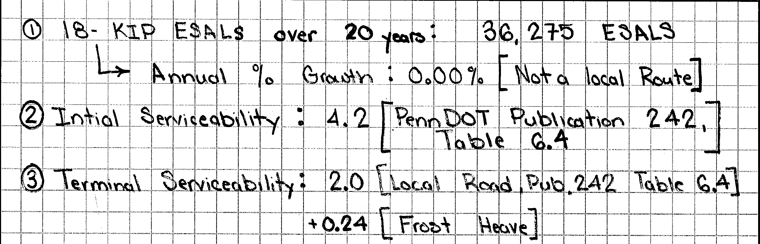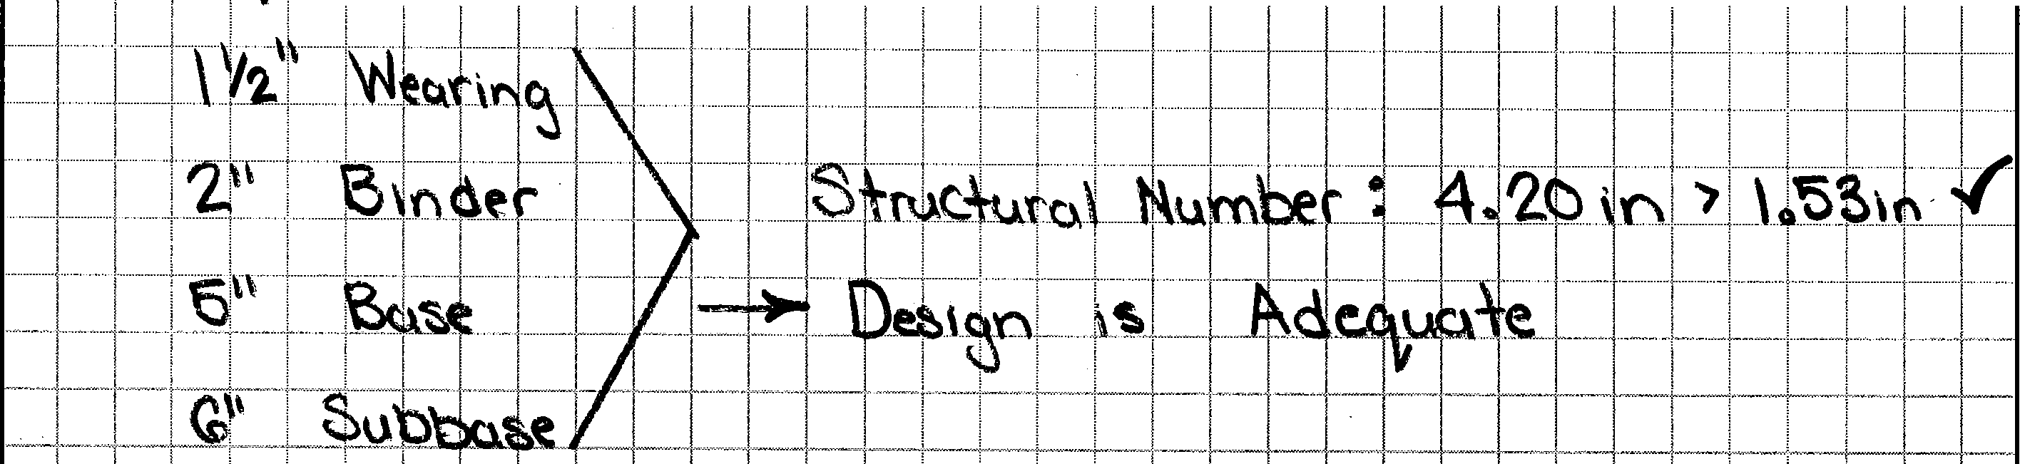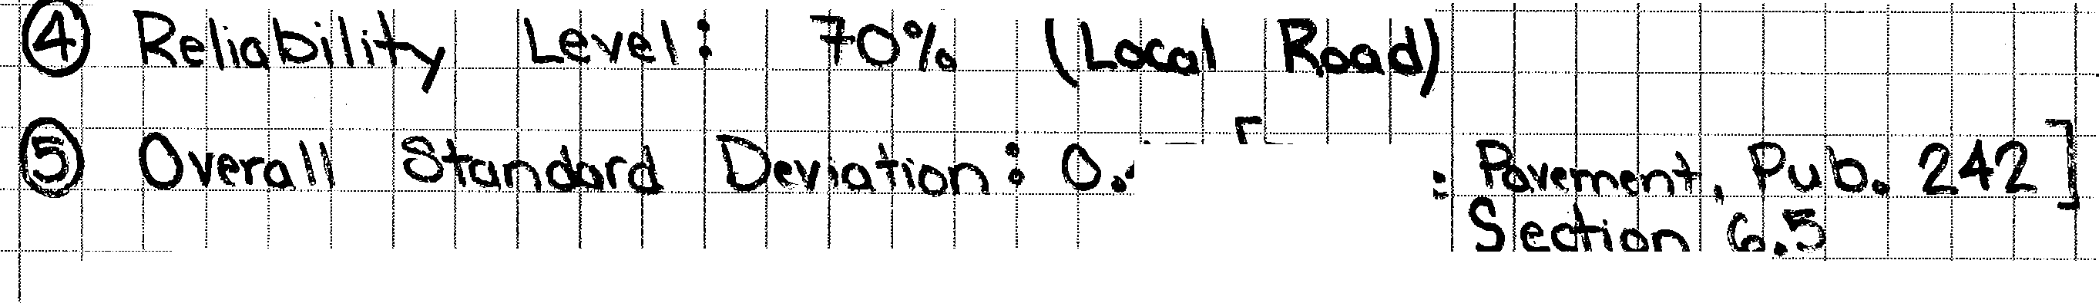--··--·---·-··-·, -. II" i
1--+----------+----iL . -·········· -· . ··--···-····-·······l·-···-····-t-········-1--···-···-···-l--············+·- ·--········---· 2 •"r -·1-i-,-+-----I ··- ···1··--t----+---1 -·-··· ··········-·· --· '--·--···-·
t l ]

l l I'++•·_..• -

(
1 - , - l · - -1 - - - r
:-_ .!cAt _ t :1\\cnf _{l\\;1} _{-r-} llrtptJ- F. t Cl (' . O())
-- -fo -- r : I, h;tio _Sf-ie6--: L -]T- --······-·EL -- 3:, - -,-
.-J l \ ¥--J)«: .il :\\}, ,1'- 'u,,..h.,1 \.S---.....µ..,1...,..t..\.+-+----1-+---+---+--f
_ icttJ_ . J _ --·- f_:tt..+,---··-1·····-·······1·····-······l-------t---+--------+--1-----+
: fo .;--i.-_;-;1 d 1 u , -,\ .. \ ('\

(
·•·· ··· ·· · --·--·-·- -·--· -·-- ·····----- 1----- ······-· --· --··-1---1--l-----1-·-------- ·------··--··....--. l -+-------1-----l-----+----i-------+ I
I .. -··········'················· ,....... • •••••••••••.•••••••••••, •••••••••••••••, •••••••••••••••••,. •• • •••, ••••••••••••••••,,...............................,................. • ' •••••••••••••••, ................. " •••••••••••, •••••••••••••••••, •••••••••• ··'·············+········+ ... ·1·· .......... ,....... ···+ ...... I ---l----l--.' , ..

INSTRUCTIONS:

PennDOT ESAL Calculator
Gale Lane Residential Development - Pavement Section

Input the required information: Current Traffic Count Year; Design Year; Performance Period; Traffic Growth Rate; Oneway/Twoway; and Number of Lanes in Design Direction. Copy the traffic count data from the RMS Traffic screen and paste into the Traffic Count table.

INPUT:

Project Identification Designer
Gale Lane Residential Development
JWJ
06/05/2018
2018
2018
10
0.00%
2
1
50.00%

Date
Current Traffic Count Year
Design Year (When construction will be completed and roadway will be opened to traffic.)
Performance Period (This is used for pavement design only. For Superpave mix design, 20 years is always used.)
Traffic Growth Rate
  - Oneway or one direction on a divided highway; (2) Twoway Number of Lanes in Design Direction
Percent Trucks in Design Direction
(This is used for twoway counts only, default is 50%. For oneway counts, 100% is always used)

Color Coding Legend
Traffic Count (from RMS) | Current Count | Design Count
TOTAL VEHICLES (ADT) | 880 | 880
TOTAL TRUCKS (ADTT) | 20 | 20
MOTORCYCLE | 0 | 0
CAR | 860 | 860
PICKUP/VAN | 0 | 0
BUS | 0 | 0
2 AXLE-SIX TIRE | 10 | 10
3 AXLE-SINGLE UNIT | 0 | 0
4 AXLE-SINGLE-UNIT | 0 | 0
3 AXLE W/ TRAILER | 0 | 0
3 AXLE-MULTI AXLE TRAILER | 0 | 0
6 AXLE-SINGLE TRAILER | 10 | 10
5 AXLE-MULTIPLE TRAILER | 0 | 0
6 AXLE-MULTIPLE TRAILER | 0 | 0
7 AXLE-MULTIPLE TRAILER | 0 | 0
Percent Trucks in Design Direction |  | 50.00%

Required user input
Optional user input
Constant from Pub 242
Output

Percent Trucks in Design Lane Pub 242 Section 7.1.4
Lanes in one direction | Percent Trucks
1 | 100%
2 | 90%
3 | 80%
Based on user input above | 100%

Superpave ESAL ranges
0 | < 0.3 million ESALs
300,000 | 0.3 to < 3.0 million ESALs
3,000,000 | 3.0 to < 10.0 million ESALs
10,000,000 | 10.0 to < 30.0 million ESALs
30,000,000 | 30.0 million ESALs and greater
See Pub 408 Appendix D for Superpave Item Numbers
OUTPUT:
Flexible ESALs | 18,138
Rigid ESALs | 30,413
Superpave Mix Design ESALs* | 36,275 | < 0.3 million ESALs

CALCULATIONS:
Vehicle Classification | Count | Percent | Rigid  Truck Factor | Rigid  Daily ESALs | Rigid  Design ESALs | Flexible  Truck Factor | Flexible  Daily ESALs | Flexible  Design ESALs | Superpave  Mix Design  ESALs
MOTORCYCLE | 0 | 0.00% | 0.00 | 0.00 | 0 | 0.00 | 0.00 | 0 | 0
CAR | 860 | 97.73% | 0.00 | 0.00 | 0 | 0.00 | 0.00 | 0 | 0
PICKUP/VAN | 0 | 0.00% | 0.00 | 0.00 | 0 | 0.00 | 0.00 | 0 | 0
BUS | 0 | 0.00% | 0.24 | 0.00 | 0 | 0.24 | 0.00 | 0 | 0
2 AXLE-SIX TIRE | 10 | 1.14% | 0.24 | 1.20 | 4,397 | 0.24 | 1.20 | 4,397 | 8,794
3 AXLE-SINGLE UNIT | 0 | 0.00% | 1.15 | 0.00 | 0 | 0.82 | 0.00 | 0 | 0
4 AXLE-SINGLE-UNIT | 0 | 0.00% | 7.00 | 0.00 | 0 | 4.50 | 0.00 | 0 | 0
3 AXLE W/ TRAILER | 0 | 0.00% | 0.60 | 0.00 | 0 | 0.44 | 0.00 | 0 | 0
3 AXLE-MULTI AXLE TRAILER | 0 | 0.00% | 1.59 | 0.00 | 0 | 1.00 | 0.00 | 0 | 0
6 AXLE-SINGLE TRAILER | 10 | 1.14% | 1.42 | 7.12 | 26,016 | 0.75 | 3.76 | 13,741 | 27,481
5 AXLE-MULTIPLE TRAILER | 0 | 0.00% | 2.40 | 0.00 | 0 | 2.33 | 0.00 | 0 | 0
6 AXLE-MULTIPLE TRAILER | 0 | 0.00% | 1.42 | 0.00 | 0 | 1.28 | 0.00 | 0 | 0
7 AXLE-MULTIPLE TRAILER | 0 | 0.00% | 1.42 | 0.00 | 0 | 1.28 | 0.00 | 0 | 0
 | 880 | 100.01% |  | 8.33 | 30,413 |  | 4.97 | 18,138 | 36,275

Roadway Management Division Revised December 16, 2008

Appendix D – Design Freezing Index and Frost Heave Worksheet Publication 242 2015 Edition

FROST HEAVE WORKSHEET

To determine the Change in Serviceability Loss Due to Frost Heave, ΔPSI_{FH}, you will need 1993 AASHTO Guide for Design of Pavement Structures.

The effects of Frost Heave must be accounted for in all full-depth flexible pavement designs and bituminous over rubblized concrete designs. To do this, follow the given steps below.

STEP #1: Determine the Frost Heave Rate, φ (mm/day)
    - Obtain the soil classification of the future subgrade at the project site.
    - Using the soil classification, determine the Average Rate of Heave from Table 9.1 or 9.2.

(Soil Classification: GM )
FROST HEAVE RATE: 4 mm/day

STEP #2: Select the Frost Heave Probability, P_{F}

1. Estimate the percent area of the project that is subject to frost heave. Consider the extent of frost-susceptible subgrade material, moisture availability, drainage quality, number of freeze- thaw cycles per year, depth of frost penetration, and past experience. (Recommended Range: 25% - 75%)

FROST HEAVE PROBABILITY:
50 %

STEP #3: Determine the Maximum Potential Serviceability Loss, ΔPSI_{MAX}
- Use Appendix D to find the Design Freezing Index for the project site.

Design Freezing Index
592

- Use Figure 9.1 to determine the Frost Penetration from the design freezing index.

Frost Penetration
34.6
inches =
2.88
feet

- Use Figure G.7 (pg. G-10) of the 1993 AASHTO Guide to determine the Max. Serviceability Loss Due to Frost Heave. Use a Drainage Quality of FAIR.

MAXIMUM POTENTIAL SERVICEABILITY LOSS:
0.50

STEP #4: Determine the Change in Serviceability Loss Due to Frost Heave, ΔPSI_{FH}
    - Use the results obtained in the first three steps to navigate through Figure G.8 (pg. G-11) of the 1993 AASHTO Guide.

CHANGE IN SERVICEABILITY LOSS DUE TO FROST HEAVE:
0.24

Once the Change in Serviceability Loss due to Frost Heave is determined (Step #4), add it to the
appropriate Terminal Serviceability Index listed in Table 6.4. Use the result as the terminal serviceability input required in DARWin for full-depth flexible pavement designs.

D - 6

Chapter 9 – Full-Depth Flexible Pavement Design Publication 242 2015 Edition

TABLE 9.1
ESTIMATED AVERAGE RATE OF HEAVE (UNIFIED SOILS CLASSIFICATION SYSTEM)
CLASSIFICATION OF SUBGRADE SOIL* | ESTIMATED AVERAGE RATE OF HEAVE  (mm/day)
GW | 2
GP | 3
GM | 4
GC | 4
GW – GM | 4
GW – GC | 3
GP – GM | 4
GP – GC | 4
GM – GC | 5
SW | 3
SP | 1
SM | 7
SC | 5
SW – SM | 7
SW – SC | 4
SP – SM | 7
SP – SC | 3
SM – SC | 5
ML | 15 - 20
CL | 8
OL | **
MH | **
CH | 1
OH | **
ML – OL | ** 15 -20
*For MFC A and MFC B pavement designs, this chart is to be used with laboratory classification of subgrade soils. For MFC C, MFC D, and MFC E pavement designs, laboratory classifications are not required (i.e., field classifications are acceptable).

**OL, MH, and OH soils do not meet minimum specifications for subgrade material. ML-OL are marginal and may or may not meet minimum specifications for subgrade.

9 - 3

Chapter 9 – Full-Depth Flexible Pavement Design Publication 242 2015 Edition

FIGURE 9.1
DESIGN CHART FOR DETERMINATION OF FROST PENETRATION
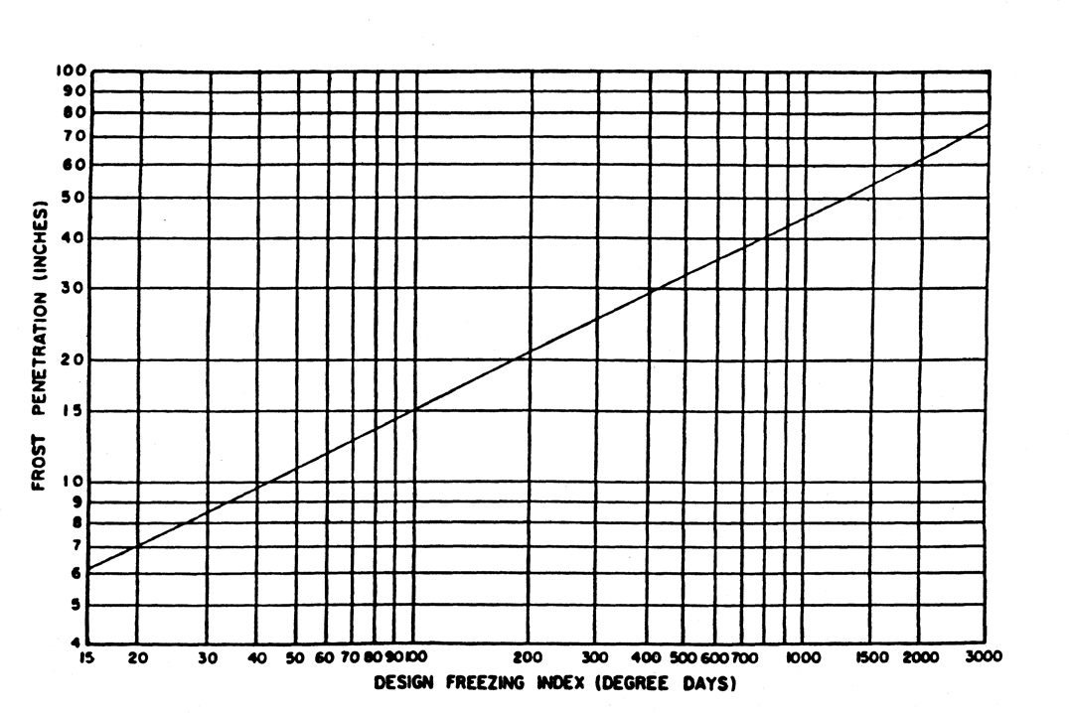
34.6" = 2.88'

NUMBER OF CONSTRUCTION STAGES

Staged construction is not to be considered. Therefore, the Number of Construction Stages shall always be set to one.

DESIGN STRUCTURAL NUMBER

Once the variables necessary for full-depth flexible design are entered, calculate the design structural number by clicking the "Calculate Button".

The resulting Design Structural Number depicts the required strength the proposed pavement will need to provide. This structural number must be converted to individual layer thicknesses of the pavement through the following equation.

SN = a₁d₁ + a₂d₂m₂ + a₃d₃m₃ + ...a_{n}d_{n}m_{n}

where: SN | = | Structural Number
a_{i} | = | Structural Coefficient for layer I
d_{i} | = | Thickness of layer I
m_{i} | = | Drainage Coefficient for layer I
 |  | 9 - 5

Appendix D – Design Freezing Index and Frost Heave Worksheet Publication 242 2015 Edition

DISTRICT 5
Location | Elevation | Index | Winter
Berks County
Reading WB | 266 | 436 | 62-63
Morgantown | 595 | 664 | 62-63
Carbon County
Palmerton | 435 | 749* | 62-63
Lehigh County
Allentown WB | 376 | 752 | 62-63
Allentown Gas | 254 | 621 | 62-63
Monroe County
Mt. Pocono 2 mi. N | 1915 | 1194 | 62-63
Stroudsburg | 480 | 987 | 62-63
Tobyhanna | 1950 | 1216 | 62-63
Schuylkill County
Port Clinton | 450 | 971* | 62-63
Northhampton County
Bethlehem (Lehigh U) | 411 | 752 | 62-63

DISTRICT 6
Location | Elevation | Index |  |  | Winter
Bucks County
George School | 135 | 685* |  |  | 60-61
Quakertown | 490 | 669* |  |  | 60-61
Chester County
Coatesville 1 mi. SW | 342 |  | 592* |  | 60-61
Devault 1 mi. W | 360 |  | 629 |  | 60-61
Phoenixville | 105 | 473 |  |  | 60-61
Delaware County
Marcus Hook | 12 | 228 |  |  | 60-61
Montgomery County
Graterford 1 mi. E | 240 | 718 |  |  | 60-61
Norristown | 75 | 355 |  |  | 62-63
Philadelphia County
Phila. Airport WB | 7 | 506 |  |  | 60-61
Drexel University | 30 | 309 |  |  | 62-63
Pt. Breeze | 32 | 184 |  |  | 62-63

D - 3

Appendix G

swelling probability, there is no clear-cut method for approximating frost heave probability
Once values for the three frost heave factors are defined, the equation for serviceability Joss (presented in Figure G 8) should be used to generate a frost heave serviceability Joss curve similar to that presented in Figure 2 2 (Part II) The time, t, used with Figure G 8 should be equal to the analysis period For stage con-
G-11

struction and rehabilitation strategies, the perform­ ance period is used The frost heave serviceability loss curve should then be combined with the swelling serv­ iceability loss curve (if applicable) to produce a total serviceaqility loss versus time curve This curve will then be used as a component of the design procedure discussed in Chapter 3, Part II

Frost Heove Rote, /6 ( mm/day)

10 20 30 40 50 60

'/
7

I/

70 80 90 100

J
j I /I I/

II
I
17

V

,
r

I
I
r,/I
17
n,, I
1}1j21J1

1 Y Ill A
V
Y
17
1/
[7

'
1/1 A Y 17
I/ 1/1/
1/1/VI/
IIIIIIU1iMttftiIEJ 11 J

I /111/1717
J
r::\.f.;f
'IV/
f's.

' '
40 35 30 25 20 15
TIME, t (years)

0.24

t---L

05r I ,, H--±, ,
0 5

NomotJroph Solves:

-( 02 , ,0 t)]
"'
,.,:-
10 I'"" I.., ,._,. I f"""-..1 l , ,
'\, '-. ""'I. I l ......._J

'",
15- '

C:.f>SIFH•OOI PF PSIMAX[ 1-e

E1omp1e;
0 .c ' ..... . ......
_,_ 's,. ' '-, I I
0 ' 20
.::20 "- "- )-...,,
.2 Ma,1mum Potential ""- I 1

t= 15 years
-i:..,
S1rv1c1abilit "- 5 ·
1

¢, 5 mm/day
P ::: 30•1.
C.PSIM4X, 2 0
Solul1on: SIFH= 0 47
l2 2 5 Lass, £>PSI MAX '-. [ "-i
<l I I I I I I 0'
3 0 1 I I I I I I I I I I I 11 N

Figure G.8. Chart for Estimating Serviceability Loss Due to Frost Heave

G-10 Design of Pavement Structures

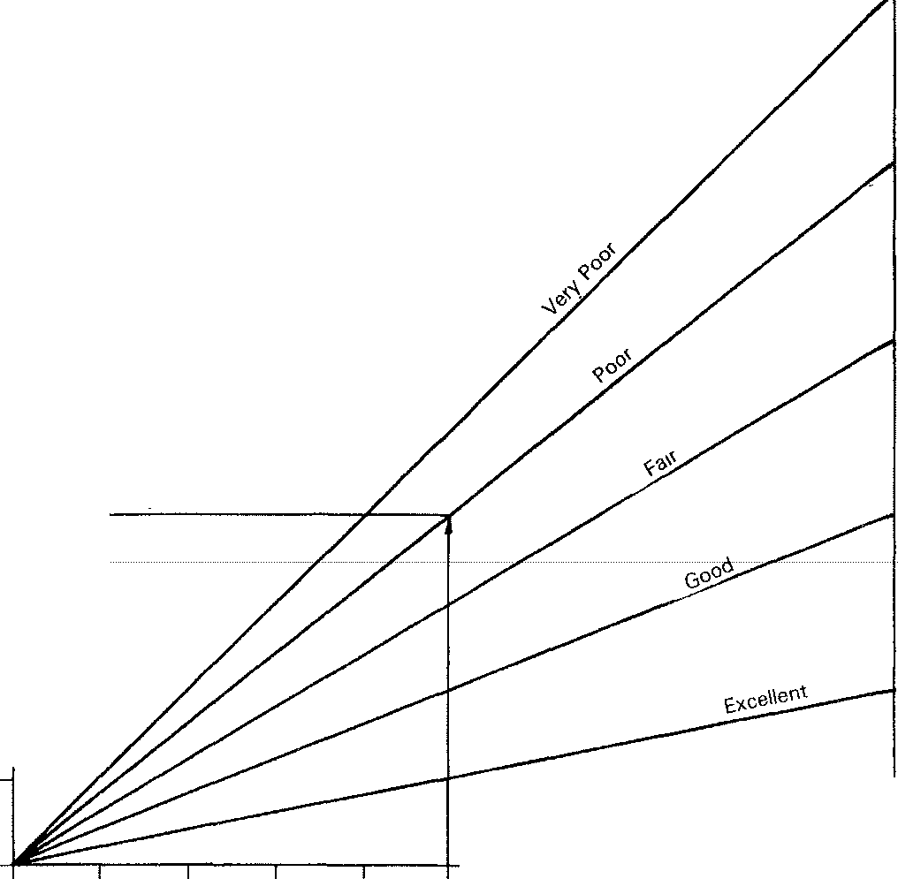5 ----------------------------

Drainage Quality
4
'!;
r ill

u..
2
!!l ³
Cl -
"> X

0"'
-J -
:<;!

>- "'

2 12 0)
J:
E
E"
x

0.87

0 15 feet)
0 2 4 6 8 10

Depth of Frost Penetration (feeti

Figure G,7. Graph for Estimating Maximum Serviceability Loss Due to Frost Heave

SERVICEABILITY LOSS DUE TO FROST HEAVE

Project: | Gale Lane Residential
Designer: | Jamie Kouch, P.E.
Date: | 06/04/2018

t | 10 | Years | Time
φ | 4 | mm/day | Frost Heave Rate, Table 9.1 or 9.2 (pg. 9-5 or 9-6) Publication 242
P_{F} | 50 | % | Frost Heave Rate Probability (Recommended Range 25% - 75%)
Design Freezing Index | 592 |  | Use Appendix D of Publication 242 to find Design Freezing Index
Depth of Frost Penetration | 2.88 | feet | Reference Figure 9.1 (pg. 9-7) of Publication 242.
ΔPSIMAX | 0.87 |  | Reference: Figure G.7 (pg G-10 AASHTO 1993 Design of Pavement Structures)
 | 34.6 | in | Note: This is only for Drainage Quality of Fair.
Reference: Figure G.8 (pg G-11 AASHTO 1993 Design of Pavement Structures)
ΔPSIFH | 0.24

