COMMONWEALTH ENGINEERS, INC.
114 East Lancaster Avenve ...., Second Floor "" Downingtown, PA 19JJ5 Telephone: (610) 518-9003,.., Fax: (610) 518-9004,..,. comeng@cei-1.com

3150-PM-BWEW0036 8/2016

LETTER FROM APPLICANT TO MUNICIPALITY AND COUNTY TO SATISFY ACTS 14, 67, 68 and 127

June 13, 2018

Ms. Laurie Prysock Township Manager
East Marlborough Township 721 Unionville Road
Kennett Square, PA 19348 Dear Ms. Prysock:
The purpose of this notice is to inform you of our intent to submit an application to the Pennsylvania Department of Environmental Protection (DEP) for
the following:

Application Type:

Applicant Name: Address of Applicant: Applicant's Agent: Project Name:
Project Location: Municipality/County: Project Description:
Chapter 105 Water Obstructions & Encroachment General Permit Registration Form GP-5 Utility Line Stream Crossing and GP-7 Minor Road Crossing
Jorge Paredes,
223 East Street Road, Kennett Square, PA 19348 Thomas Tran, P.E., Commonwealth Engineers, Inc. 223 E. Street Road
223 East Street Road, Kennett Square, PA 19348 East Marlborough Township, Chester County, PA
A 2-lot subdivision is proposed. Lot 2 will contain the existing single-family home. Lot 1 proposes a single-family dwelling and driveway on approximately 3.866 acres. A section of the driveway will cross East Branch Red Clay Creek.

Section 1905-A of the Commonwealth Administrative Code, as amended by Act 14, requires that each applicant for a DEP permit must give written notice to the municipality and the county in which the permitted activity is located . The written notices shall be received by the municipality and county at least 30 days before the Department may issue or deny the permit.

"Acts 67 and 68, which amended the Municipalities Planning Code to support sound land use practices and planning efforts, direct state agencies to consider comprehensive plans and zoning ordinances when reviewing applications for permitting of facilities or infrastructure, and specify that state agencies may rely upon comprehensive plans and zoning ordinances under certain conditions as described in Sections 619.2 and 1105 of the Municipalities Planning Code. Enclosed is a General Information Form (GIF) we have completed for this project. DEP invites you to review the attached GIF and comment on the land use aspects of this project; please be specific to DEP when identifying any areas of conflict. If you wish to submit comments for DEP to consider in a land use review of this project, you must respond within 30 days to the DEP regional office listed below. If there are no land use comments received by the end of the comment period, DEP will assume that there are no substantive land use conflicts and proceed with the normal application review process."

Please submit any comments concerning this project within 30 days from date of receipt of this letter to the DEP Waterways and Wetland Program at the PaDEP Southeast Regional Office, 2 East Main Street, Norristown, PA 19401-4915, (484) 250-5900.

For more information about this land use review process, please visit www.dep.pa.gov, (keyword: Land Use Reviews) .

If you have any questions, please do not hesitate to contact me. Sincerely,

Thomas Tran, P.E.
Project Engineer

Via US Mail, Certified Mail, Return Receipt Requested: 7016 0910 0002 0353 5543

G:\ACTIVE JOBS\2016\201656 Spano (223 East Street Road)\GP-5 PERMIT\201656 Act 14_Twp_GP-5-7 _2018_06-13.doc

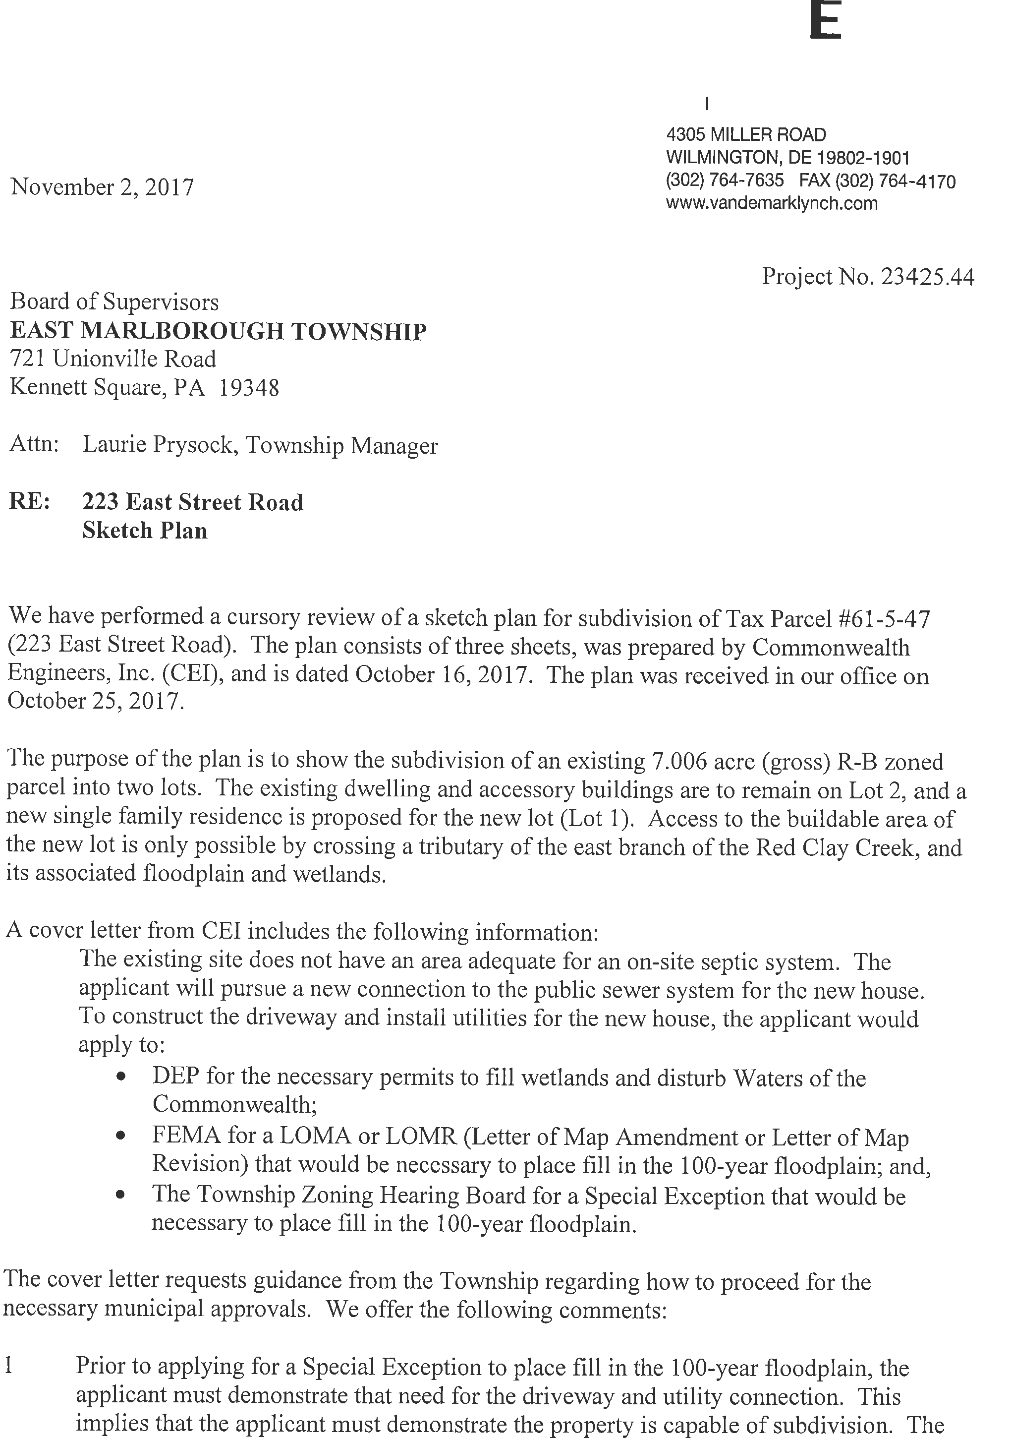

Board of Supervisors, East Marlborough Township
RE: 223 East Street Road Sketch Plan

November 2, 2017
Page 2 of 3

information provided with the submitted Sketch Plan does not meet this threshold, as explained below:

- The existing floodplain should be shown based on the latest FIRM maps, dated September 29, 2017. (Section 4.01.A of Ordinance No. 2017-03) Sheet 1 of the Sketch Plan is an Existing Conditions Plan. The sheet does not show the floodplain boundary, although the legend includes a symbol for the "Flood Hazard District Line", and General Note #13 states the "FEMA Floodplain Boundary [is] taken from Flood In urance Rate Map, Panel 205, Map Number 42029C0250F, dated September 29, 2006."

- Sheet 2 shows a "100-year floodplain boundary", and General Note #13 on sheet 2 states the "100-year floodplain boundary [is derived] from HEC-RAS model created by Commonwealth Engineers, Inc. in March 2017." The floodplain boundary shown on sheet 2 is not the current regulatory floodplain shown on the FIRM map referenced in comment #1 above. The engineer should show the existing floodplain based on the current FIRM map. We suggest the engineer also review Sections 4.01, 4.02.C, and 4.03 of Ord. 2017-03 to determine whether modification of the FIRM map floodplain can be justified.

- On sheets 2 and 3 of the plan, the gross and adjusted areas are noted for both lots. The plans do not provide any calculations that demonstrate how the adjusted acreage was computed. It appears the calculation is based on the gross area minus 75% of the area within the wetlands and the floodplain, and it appears the calculation is based on the computed HEC-RAS floodplain and not the regulatory floodplain. (Refer to comments #1 and #2 above.) The calculation for adjusted area should be based on the regulatory floodplain. The plan should also clearly note that there are no specimen trees on the property, or if there are, account for them in the calculation for adjusted area. Please note that our estimation of the adjusted area for the parcel, based on the FIRM map, is less than 160,000 square feet, which implies the parcel is not large enough for two 80,000 sf lots.

- When identifying the Special Exception that would be necessary for the project, the cover letter from CEI references Sections 1303.B.7 and 1303.B.8 of the Zoning Ordinance. These references are not current. The correct references should be Sections 5.01.F(2)(i) and 5.01.F(2)(j) of Ord. No. 2017-03.

- The plans show proposed culverts to allow the proposed driveway to cross the wetlands and stream. No calculations for these structures have been submitted, so we can make no comment on their adequacy at this time.

- Sheets 2 and 3 include zoning data tables, but the data for the maximum lot coverage has been left blank. We estimate the lot coverage for Lot 2 will exceed the 10% limit, and

